Use testing

select * from Employees

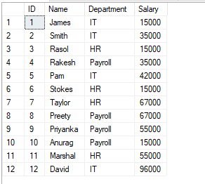

SELECT

Department,

COUNT(*) AS NoOfEmployees,

SUM(Salary) AS TotalSalary,

AVG(Salary) AS AvgSalary,

MIN(Salary) AS MinSalary,

MAX(Salary) AS MaxSalary

FROM Employees

GROUP BY Department

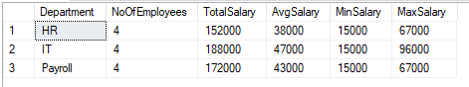

select

e.* ,

max(salary) over(partition by department order by salary desc) as salary_Max , min(salary) over() as minimum ,

avg(salary) over() as salary_total

from Employees e

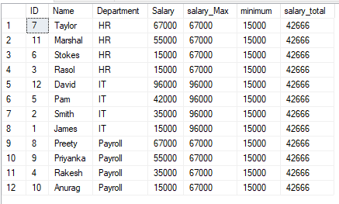

SELECT Name,

Salary,

Department,

COUNT(Department) OVER(PARTITION BY Department) AS DepartmentTotals,

SUM(Salary) OVER(PARTITION BY Department) AS TotalSalary,

AVG(Salary) OVER(PARTITION BY Department) AS AvgSalary,

MIN(Salary) OVER(PARTITION BY Department) AS MinSalary,

MAX(Salary) OVER(PARTITION BY Department) AS MaxSalary

FROM Employees

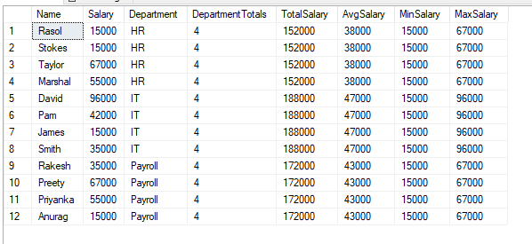

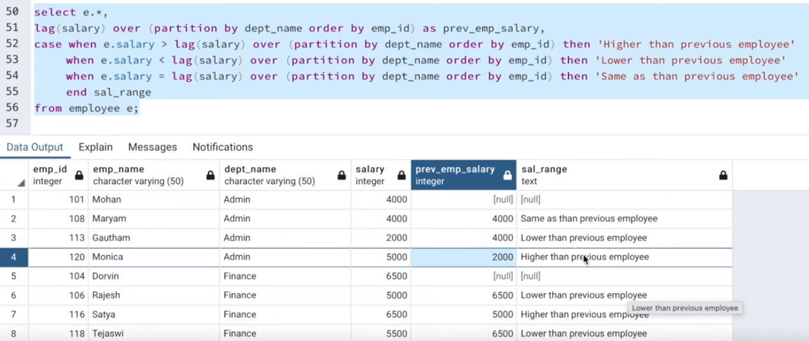

SELECT

Name,

Salary,

Department,

avg(Salary) OVER (PARTITION BY Department ) as avg_sal ,

CASE

WHEN SALARY > avg(Salary) OVER (PARTITION BY Department )

THEN 'salary more than avg'

WHEN SALARY < avg(Salary) OVER (PARTITION BY Department )

THEN 'salary less than avg'

END as STATUS

FROM Employees

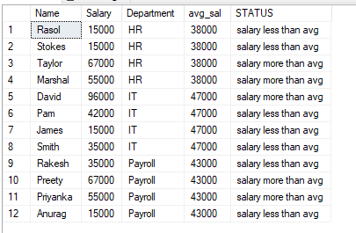

Occupation TABLE =

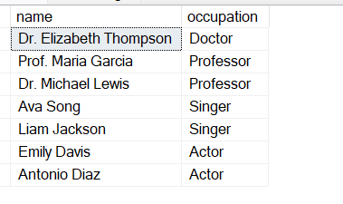

SELECT name,

CASE

WHEN occupation = 'Doctor'

THEN name -- this name will displayed in Doctor col

END as 'Doctor', -- whole column name will be doctor.

CASE

WHEN occupation = 'Professor'

THEN name

END as 'Professor',

CASE

WHEN occupation = 'Singer'

THEN name

END as 'Singer',

CASE

WHEN occupation = 'Actor'

THEN name

END as 'Actor',

ROW_NUMBER() OVER (PARTITION BY occupation ORDER BY name) as rowcolumn

FROM occupations

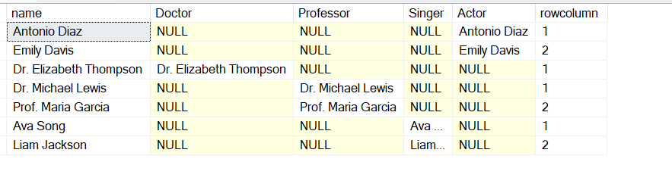

--Create View

alter VIEW vw_doctor_prof_singer_actor AS (

SELECT name,

CASE

WHEN occupation = 'Doctor'

THEN name -- this name will displayed in Doctor col

END as 'Doctor', -- whole column name will be doctor.

CASE

WHEN occupation = 'Professor'

THEN name

END as 'Professor',

CASE

WHEN occupation = 'Singer'

THEN name

END as 'Singer',

CASE

WHEN occupation = 'Actor'

THEN name

END as 'Actor',

ROW_NUMBER() OVER (PARTITION BY occupation ORDER BY name) as rowcolumn

FROM occupations

);

--Run view

SELECT

MAX(Doctor) as doctor ,

MAX(Professor) as professor ,

MAX(Singer) as singer,

MAX(Actor) as Actor

FROM vw_doctor_prof_singer_actor

GROUP BY rowcolumn

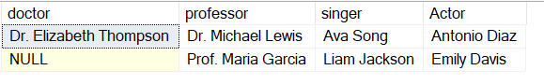

When to use row number =

We have student table . and we want to give unique roll number to each student based on class.

SELECT *,

ROW_NUMBER() OVER(Partition by class ORDER BY class) AS roll number,

FROM

student;

RANK =

Name of employee having Max salary in his department =

WITH I AS

(

SELECT EMPFNAM, DEPARTME, SALARY,

DENSE_RANK() OVER (PARTITION BY DEPARTME ORDER BY SALARY DESC) AS R,

MAX(SALARY) OVER (PARTITION BY DEPARTME ORDER BY DEPARTME) AS MAXSALARY

FROM EMPLOYEEINFO EI

INNER JOIN EMPLOYEEPOSITION EP

ON EI.EMPID = EP.EMPID

)

SELECT * FROM I

WHERE R=1

